***C 3 – asynchronous work***

***4. Look at the list of sections on the form (1-10) and match each one to Eriko’s notes on the information she needs to provide (a-j).***

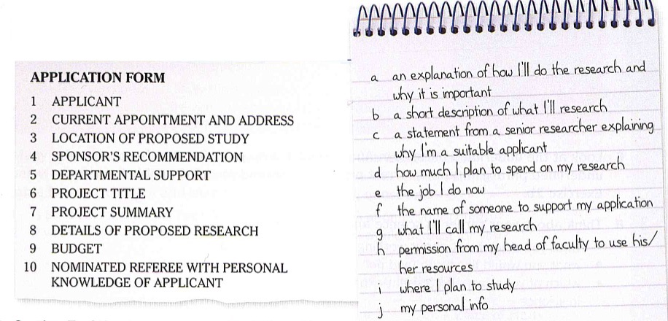

Write your answers here

a 🡪 8 c 🡪 10 e🡪 2 g 🡪 6 i 🡪 3

b 🡪 7 d 🡪 9 f 🡪 4 h 🡪 5 j 🡪 1

***4c. Section 7 of the of the form asks applicants to write a project summary of their research proposal. Think about a research topic in your area. Summarize the project following the instructions (1-6) below.***

1. State the aims of your research;
2. Identify the area for new work;
3. Explain why your topic/project is worth researching/endorsing;
4. Say what the expected outcomes (concrete goals and deliverables) are;
5. Outline the methodology you will follow;
6. Outline the limitations of your project;

***Extension activity Once you have laid out the draft of your research summary you may consider the following sense-making CRM (Computing Research Methods) framework which describes the cycle of research. Each question (1-4) anchors a quadrant in the process of computing research.***

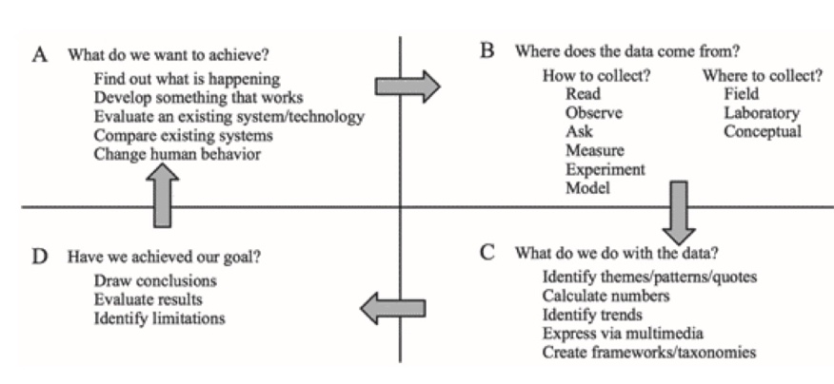

***4d. Match the highlighted section in the summary (A-F) to the correct function from the list in exercise 4c.***

**Next-Generation Transport Protocols for Ultra-High Speed Networks**

End-to-end data transfer rate requirements in the physics and astronomy scientific computation communities are soon to approach the terabit-per-second regime. (A) **However**, even when sufficient raw transmission capacity is available at individual links and routers traversed on an Internet path, such capacity cannot be made available to applications if the underlying transport protocols do not scale correspondingly. (B) **In this project, we consider** a novel paradigm for end-to-end congestion control that can help scale transport protocols to such ultra-high network speeds. (C) **We argue that it is possible** to design a novel paradigm of *packet-scale congestion- control*, in which the protocol operates at a frequency close to the frequency of packet transmissions. (D) **This paradigm allows** the congestion-control timescale to be shrunk by several orders of magnitude over current protocols, especially in high-speed networks. (E) **The innovativeness and nature of this project requires a research methodology** that adopts both *theoretical analysis and formal modeling*, as well as *practical system design, implementation, and experimentation* on wide-area high-speed networks. (F) **This project should produce** a *significant performance leap*—while the best of current protocols are struggling to achieve 10Gbps transfer speeds, the paradigm enables comfortable operation at terabit- and-higher speeds. This is the *first* end-to-end congestion-control protocol for TCP/IP networks to achieve this scale.

Write your answers here

1. State the aims of your research; 🡪 (C)
2. Identify the area for new work; 🡪 (B)
3. Explain why your topic/project is worth researching/endorsing; 🡪 (D)
4. Say what the expected outcomes (concrete goals and deliverables) are; 🡪 (F)
5. Outline the methodology you will follow; 🡪 (E)
6. Outline the limitations of your project; 🡪 (A)

*5a. Complete the project summary by another researcher below using only the correct word or phrase from the box.*

|  |
| --- |
| the proposed research, although, the state of the art, to demonstrate, this project explores, tested and applied, however, to achieve this, addressed, existing methods, this model, aims to, this work, to mitigate |

Fluid phenomena play important roles in everyday life - jet streams, chemical dispersion, granular flows, et cetera. 1)___________ these phenomena are commonplace, mathematical models that describe them properly are nonlinear and lead to computational simulation processes that are very complex and challenging to perform efficiently. 2)______________ the phenomena of high-energy fluid elastic solid interaction. 3)________________ for this type of interaction are better suited for lower energy scales. 4)___________ this work 5)___________ capture shocks and other phenomena requiring compressible flows in a high-energy state. 6)______________, we employ a method known as *Residual Distribution Scheme* (RDS) for the fluid simulation [Roe 1987]. Our method has been 7)___________ to a number of challenging problems with applications in computer animation: (a) foggy air current speeding past an iconic bridge, rocking it back and forth, (b) a flow of solar particles passing over a space station suspended high above the Earth, (c) wind buffeting a skyscraper, causing it to bend and twist. 8)______________ the scalability of RDS, we have implemented our algorithm with the parallization facilities provided by OpenMP. 9)__________ of parallel computing is well-suited to the multi-core, shared-memory architectures commonly available on desktop workstations and laptops. 10)_________________ will also be directly applicable to many-core architectures.

Write your answers here

1 🡪 However 2 🡪 This project explores 3🡪 Existing methods 4🡪

6🡪 To demonstrate 7🡪 Tested and applied 8🡪 To demonstrate 9🡪 The state of the art

10🡪The proposed project

***5b. Write a short summary (150-200 words) for the research you discussed in exercise 4c. above. Use the phrases you noted in exercise 4d and 5a.***

Write your summary here

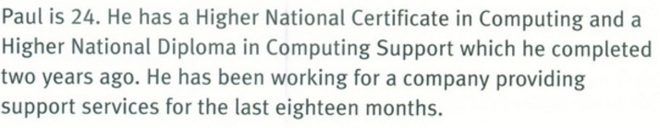

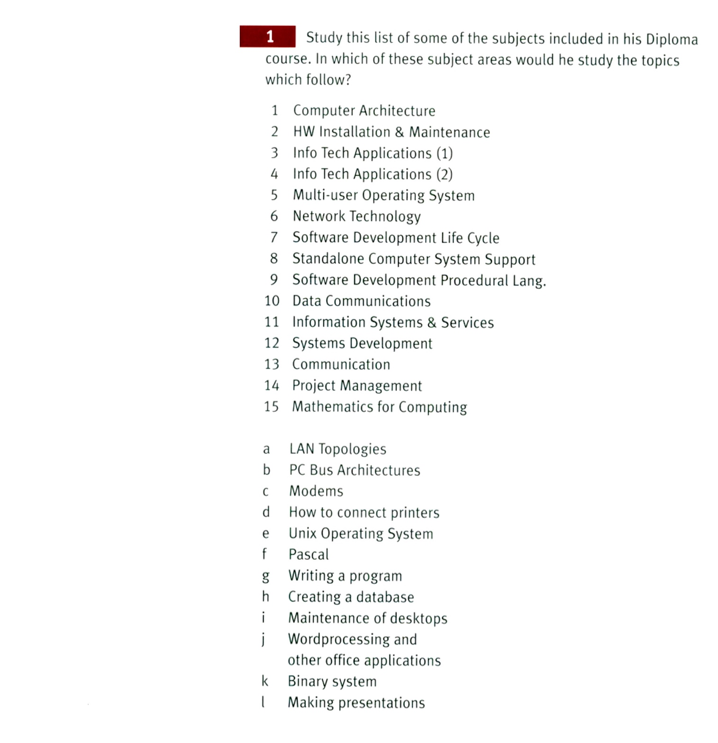

.

Write your answers here

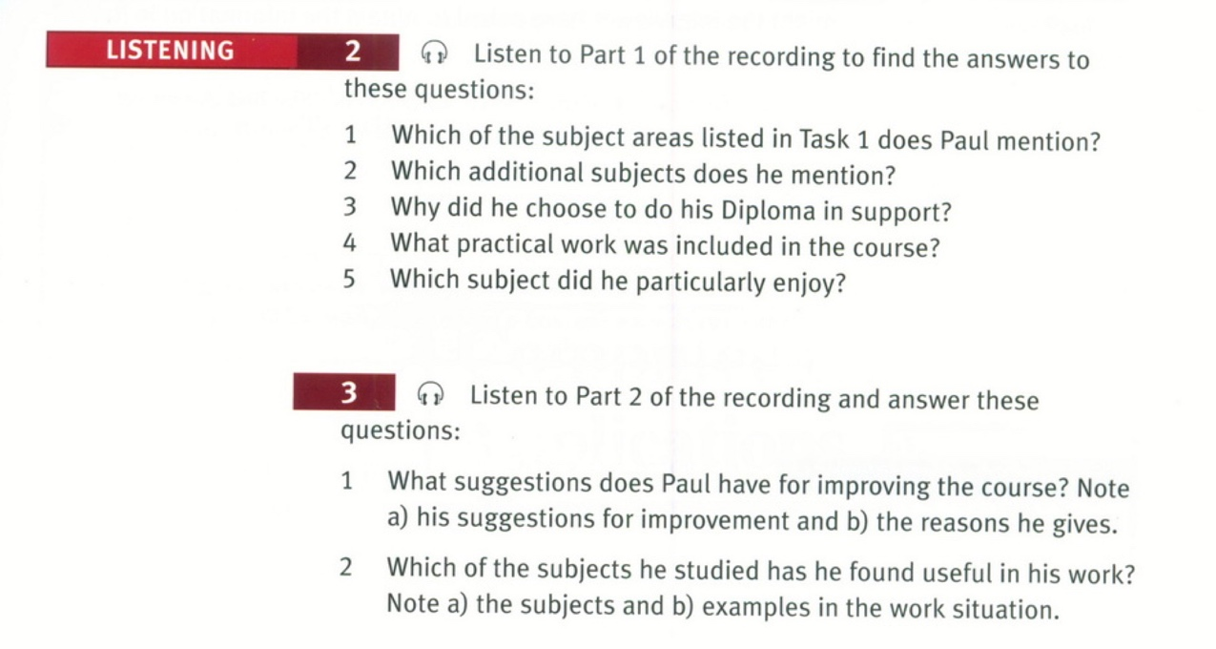

Find **Track 8** and **Track 9** in your C3 file.

Write your answers here